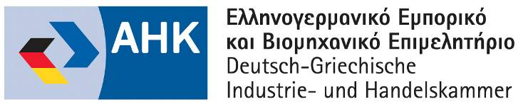



GREEK BUSINESS DELEGATION to LATIN AMERICA 3rd-9th June 2018
ARGENTINA-Buenos Aires 4-5/6, CHILE-Santiago 6-7/6, PERU-Lima 8-9/6

organisation: Hellenic-German Chamber of Commerce and Industry
Greek-Latin American Business Council
with the support of: Enterprise Greece
Ministry of Foreign Affairs
Greek Embassy in Buenos Aires-Commercial Office
Greek Embassy in Santiago
Greek Embassy in Lima
Local Bilateral German Chambers
REGISTRATION FORM
please send to: y.patsiavos@ahk.com.gr

Company:

Company profile/activity, brief description of products/services:

Participant:

Position:

Address:

E-mail: web:

tel: mobile:

B2B MEETINGS REQUEST

Type of Latin American companies you wish to meet (sector, activity):

Type of cooperation you are seeking (i.e. export/import, representation, joint-venture, investment, etc.)

